Rice Diversity from Seed to Fork: a Living Lab for Organic Rice in Northern Italy

Matteo Petitti^{1*}, Giuseppe De Santis¹, Salvatore Ceccarelli², Rachele Stentella¹, Michele Salvan^{1, 3}, Bettina Bussi¹, Riccardo Bocci¹, Daniela Ponzini¹

¹Rete Semi Rurali, Italy
²Consultant Free Lance, Italy
³University of Turin, Italy

Italy is the largest European rice producer, with 1,459,310 tons produced on 227,040 ha in 2021. Organic rice production has been steadily growing: in 2021, the area of organic rice was estimated at over 15 thousand hectares. However, rice varieties used in organic farming have been mostly developed by conventional breeding programmes, and are not well adapted to Organic Rice Farming Systems (ORFS). Furthermore, there is virtually no certified-organic rice seed available on the market, forcing all organic rice growers to either use their own seed, or resort to derogation for using of non-organic untreated seed.
To address the lack of cultivars adapted to ORFS, Italian NGO Rete Semi Rurali collected and multiplied rice germplasm from national gene banks and international research centres, thanks to the multilateral system of the International Treaty on Plant Genetic Resources for Food and Agriculture (ITPGRFA). In 2019 and 2020, Multi Environmental Trials (MET) were conducted in four organic farms in Lombardy and Piedmont regions, assessing 21 different cultivars – including a mixture – for agronomic traits and farmers’ preferences (De Santis et al., 2021). Results showed strong Genotype by Environment Interactions (GEI) for all entries, and indicated a good combination of yield, yield stability and disease resistance for the rice mixture, highlighting the need for decentralised participatory selection in ORFS. In 2019, a collection of 264 Italian rice varieties, including 214 accessions obtained from the International Rice Research Institute (IRRI) in the Philippines, was multiplied on an organic farm. Based on the preference ranking by farmers, maturity time and grain size three mixtures were assembled: a short grain (11 varieties), a medium grain (16 varieties), and a long grain (25 varieties). Between 2020 and 2022, the three rice mixtures were multiplied in four organic farms, becoming Dynamic Populations (DP) (Costanzo et al., 2019). Meanwhile, dehulling and polishing tests were conducted on the DPs’ paddy rice, showing processing yields comparable to those obtained by uniform varieties. Quantitative Descriptive Analysis (QDA) panel tests were conducted with the DPs’ rice growers (2021) and with consumer group representatives (2022). Further panel tests involving citizens on the medium grain rice DP took place during a farm day in 2022, where a professional chef prepared a risotto, and through distribution of 500 g packets to consumer groups with associated survey on the cooking and qualitative aspects of the medium grain rice DP. All these tests showed good appreciation by consumers.
During this process, a group of farmers, an organic rice seed company and rice processors started a close collaboration, becoming effectively a Living Lab, with the innovations being the rice DPs.
The current objective is to start certified seed production for the rice DPs, thanks to the European Organic Regulation (EU 2018/848), which allows the marketing of seed of non-uniform cultivar as Organic Heterogeneous Material. This would offer to organic rice growers, citizens and consumer a new product, which is beneficial for the ORFS, biodiversity and the organic rice value chain.
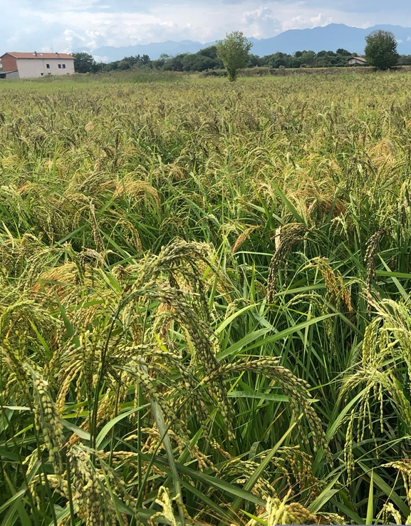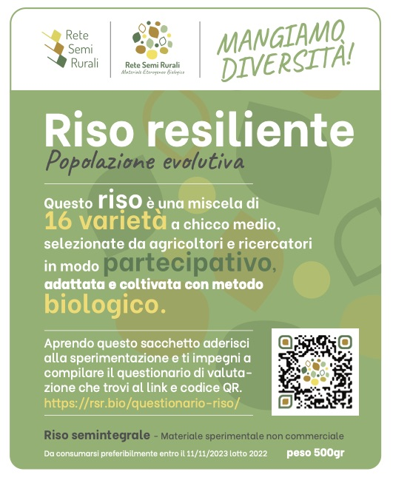

Fig. 1. Medium grain dynamic population growing at Una Garlanda, Rovasenda (VC), Italy 2022 |  | Fig. 2. Medium grain dynamic population rice packet distributed to consumer groups in Italy in 2022/2023. The label explains how the DP was constituted and includes a link for the evaluation.

Key words: organic rice systems, dynamic populations, climate change, participatory plant breeding
References:
Costanzo, A., Bickler, C. Nuijten, E., Rey, F. and Messmer, M. 2019. Proposal for a toolbox for identification and description of organic heterogeneous material. Deliverable 2.8 - LIVESEED project – www.liveseed.eu [accessed May 2023]
De Santis, G., Ponzini, D., Stentella, R., Gaifami, T., Bussi, B., Caimo-Duc, R., Stocchi, U., Cuneo, M., Paravicini, M., Bocci, R., Petitti, M., and Ceccarelli, S. 2022. Participatory Evaluation of Rice Varieties for Specific Adaptation to Organic Conditions in Italy. Sustainability, 14(17), p.10604.
Acknowledgements: This research received funding from the Cariplo Foundation (Riso Resiliente 2.0 project) and the European Union (Horizon Europe LIVESEEDING project)

*Corresponding author: Matteo Petitti
Position: Action Research coordinator
Affiliations: Rete Semi Rurali
Country: Italy
E-mail: matteo.petitti@rsr.bio

FAOSTAT - www.fao.org/faostat/ [accessed May 2023]
SINAB – Bio in cifre 2022 – www.sinab.it [accessed May 2023]

